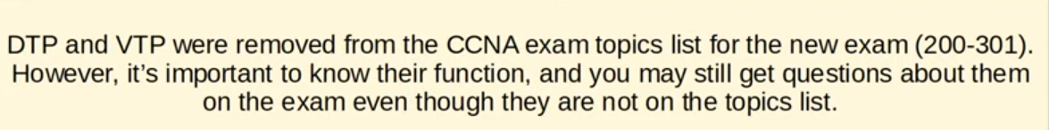
Note:

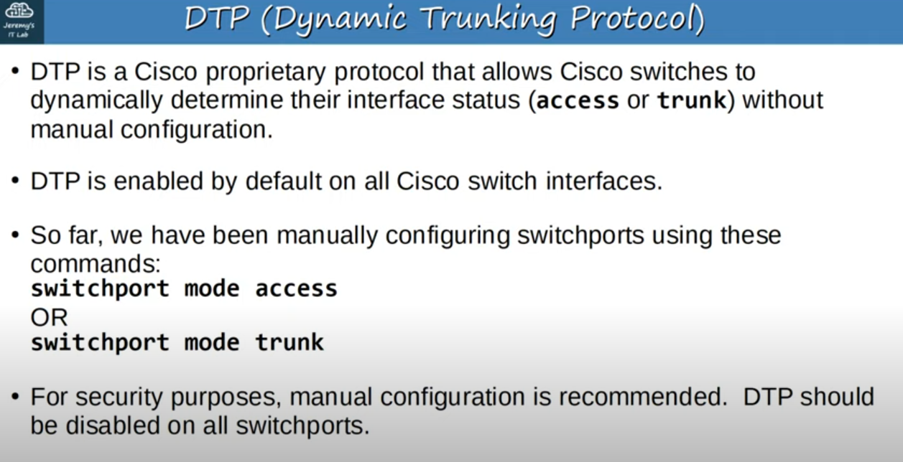
DTP

Note:(continuing first point) Basically two switches connected together can form a trunk but otherwise the interface will automatically be access port.

Note: (continuing last point)DTP can be exploited by attackers,so it should be disabled for security reasons.

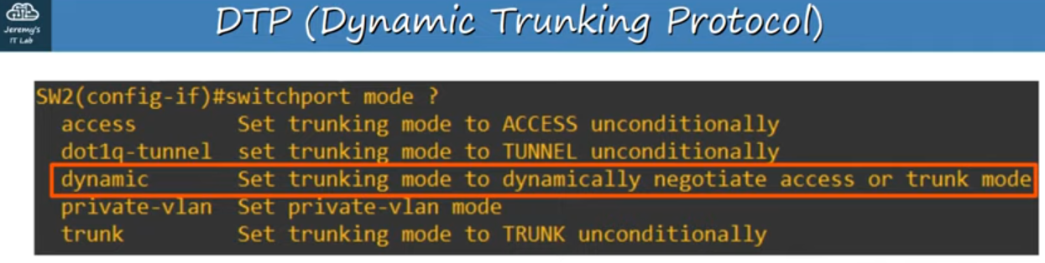
About another switchport mode

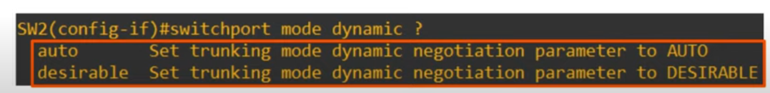
About two options of ‘switchport mode dynamic’

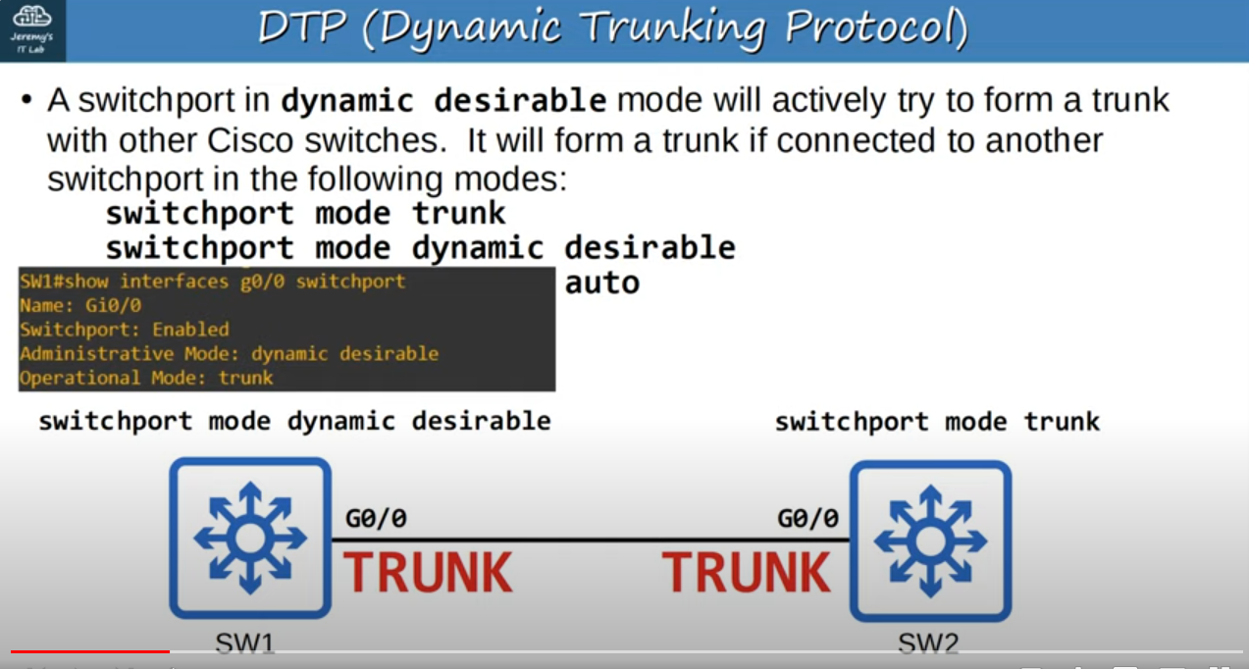
‘show interfaces <interface_name> switchport’ command output(first few lines)

Note: Switchport is enabled because it is Layer 2 port.

Note: Even if manually configured as trunk an interface still sends DTP frames out of the interface.

